CSA0502 – QUERY PROCESSING FOR DATASCIENCE
Lab Programs
17. Split DataFrame by School Code and Find Mean, Minimum, and Maximum Age
Aim
To split the DataFrame based on School Code and find the mean, minimum, and maximum age of students for each school.
Code
import pandas as pd

# Create DataFrame
data = {
"School_Code": ["S1", "S1", "S2", "S2", "S3", "S3"],
"Student_Name": ["Alice", "Bob", "Charlie", "David", "Eva", "Frank"],
"Age": [15, 16, 14, 17, 15, 18]
}

df = pd.DataFrame(data)

print("Original DataFrame")
print(df)

# Group by School_Code
result = df.groupby("School_Code")["Age"].agg(["mean", "min", "max"])

print("\nMean, Minimum and Maximum Age")
print(result)
Output
Original DataFrame

School_Code Student_Name Age
0 S1 Alice 15
1 S1 Bob 16
2 S2 Charlie 14
3 S2 David 17
4 S3 Eva 15
5 S3 Frank 18

Mean, Minimum and Maximum Age

mean min max
School_Code
S1 15.5 15 16
S2 15.5 14 17
S3 16.5 15 18
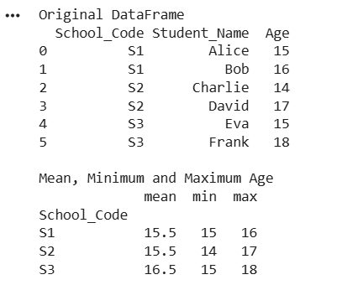
Result
The DataFrame was successfully grouped by School Code, and the mean, minimum, and maximum age for each school were calculated.

18. Split DataFrame into Groups Based on School Code and Class
Aim
To split the DataFrame into groups based on School Code and Class.
Code
import pandas as pd

# Create DataFrame
data = {
"School_Code": ["S1", "S1", "S2", "S2", "S3", "S3"],
"Class": [10, 9, 10, 9, 10, 9],
"Student_Name": ["Alice", "Bob", "Charlie", "David", "Eva", "Frank"],
"Age": [15, 16, 14, 17, 15, 18]
}

df = pd.DataFrame(data)

print("Original DataFrame")
print(df)

# Group by School_Code and Class
groups = df.groupby(["School_Code", "Class"])

print("\nGrouped Data")

for name, group in groups:
print("\nGroup:", name)
print(group)
Output
Original DataFrame

School_Code Class Student_Name Age
0 S1 10 Alice 15
1 S1 9 Bob 16
2 S2 10 Charlie 14
3 S2 9 David 17
4 S3 10 Eva 15
5 S3 9 Frank 18

Grouped Data

Group: ('S1', 9)
School_Code Class Student_Name Age
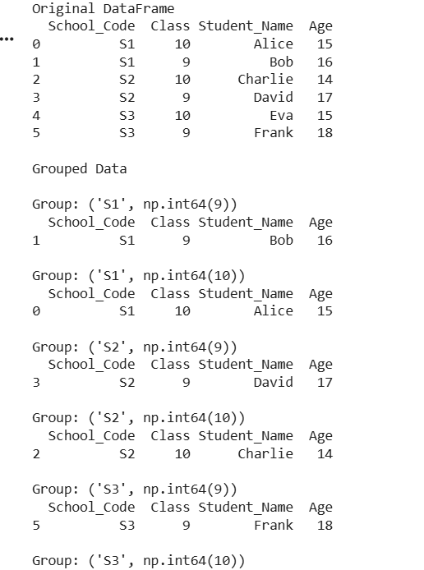
Result
The DataFrame was successfully split into groups based on School Code and Class using the groupby() function.

